CS162 ASSIGNMENT 1

NAME:

ARCHIT AGRAWAL

ROLL NO. :

202052307

SECTION:

A

## Creating a class named Main and defining the functions listed below in it

1. division(int, int)

2. gcd(int, int)

3. lcm(int, int)

4. power(int ,int)

5. max(int[])

6. min(int[])

7. abs(int)

8. factorial(int)

9. sum(int[]) (e.g. sum[1, 7, 3] output:- 1+7+3 = 11 )

10. sumOfDigits(int) (e.g. sumOfDigits(4785) output:- 4+7+8+5 = 24)

11. sqrt(int) (Note:- Don’t use Math.sqrt())

12. isPrime(int)

13. isLeapYear(int)

14. isPalindrome(int)

15. isArmstrong(int)

16. ArithmeticSequenceSum(int a, int d, int n)

“a” as the first term ,“d” the common difference between the terms and “n” is the total number of terms in the sequence.

17. GeometricSequenceSum(int a, int r,int n)

“a” as a start term , “r” as a common ratio and “n” is the total number of terms in the sequence.

18. Linear Search (return an index of element if found otherwise return -1)

CODE:

import java.util.*;  
  
public class Main {  
  
 public static double division(int a,int b){  
 if(b!=0){  
 double c = ((double)a)/b;  
 return c;  
 }  
 else{  
 System.*out*.println("Division by 0 is undefined");  
 return -1;  
 }  
 }  
  
 public static int gcd(int a,int b){  
  
 if(a == 0 && b == 0){  
 System.*out*.println("GCD is not defined");  
 return -1;  
 }  
 else{  
 int temp;  
 while(b > 0){  
 temp = b;  
 b = a % b;  
 a = temp;  
 }  
 return a;  
 }  
 }  
  
 public static int lcm(int a,int b){  
 if(a == 0 && b == 0){  
 System.*out*.println("LCM is not defined");  
 return -1;  
 }  
 else{  
 int temp;  
 int tempA = a;  
 int tempB = b;  
  
 while(tempB > 0){  
 temp = tempB;  
 tempB = tempA % tempB;  
 tempA = temp;  
 }  
 return (a * b)/tempA;  
 }  
 }  
  
 public static double power(int a,int p) {  
 long x = 1;  
 int temp = p;  
 if(p < 0) p = -1 * p;  
 while(p != 0){  
 x = x * a;  
 p--;  
 }  
 return temp > 0 ? x : 1.0/x;  
 }  
  
 public static int max(int a[]){  
 int max = a[0];  
 int x = 0;  
 for(x = 1;x < a.length; x++){  
 if(a[x] > max)  
 max = a[x];  
 }  
 return max;  
 }  
  
 public static int min(int a[])  
 {  
 int min=a[0];  
 int x=0;  
 for(x=1;x<a.length;x++)  
 {  
 if(a[x]<min)  
 min=a[x];  
 }  
 return min;  
 }  
  
 public static int abs(int a){  
  
 return (a > 0) ? a : (0 - a);  
 }  
  
 public static long factorial(int num){  
 if(num < 0){  
 System.*out*.println("Factorial is undefined");  
 return -1;  
 }  
 int i;  
 long f = 1;  
 for(i = num ; i >= 1 ; i--){  
 f = f*i;  
 }  
 return f;  
 }  
  
 public static int sum(int a[]) {  
 if(a.length <= 0){  
 System.*out*.println("Array size cannot be less than or equal to 0");  
 return -1;  
 }  
 int s = 0, x;  
 for(x = 0; x < a.length; x++){  
 s += a[x];  
 }  
 return s;  
 }  
  
 public static int sumOfDigits(int n){  
 int s = 0;  
 while(n>0){  
 s += (n % 10);  
 n = n/10;  
 }  
 return s;  
 }  
  
 public static double sqrt(int n) {  
 if(n < 0){  
 System.*out*.println("Square root is undefined");  
 return -1;  
 }  
 double min = 0.0, max = n;  
 double sqrt = (min + max)/2.0;  
 while(true){  
 sqrt = (min + max)/2.0;  
  
 if(sqrt * sqrt < n - 0.00001){  
 min = sqrt;  
 } else if(sqrt * sqrt > n + 0.00001) {  
 max = sqrt;  
 } else break;  
 }  
 return sqrt;  
 }  
  
 public static boolean isPrime(int n) {  
 int x, f = 0;  
 for (x = 2; x < n; x++) {  
 if (n % x == 0) {  
 f = 1;  
 break;  
 }  
 }  
 return f == 0;  
 }  
  
 public static boolean isLeapYear(int year){  
  
 return (year % 400 == 0) || (year % 4 == 0 && year % 100 != 0);  
  
 }  
  
 public static boolean isPalindrome(int num){  
 int rev = 0;  
 int n = num;  
 while(n > 0){  
 rev = rev * 10 + n % 10;  
 n = n/10;  
 }  
 return rev == num;  
 }  
  
 public static boolean isArmstrong(int num) {  
 int s = 0, r, n = num;  
 while(n > 0){  
 r = n%10;  
 s = s + (r*r*r);  
 n = n/10;  
 }  
 return s == num;  
 }  
  
 public static long arithmeticSequenceSum(int a, int d, int n){  
  
 return ((2 * a + (n - 1) * d) * n) / 2;  
 // ((2 * a + (n - 1) * d) * n) is always even  
  
 }  
  
 public static long geometricSequenceSum(int a, int r,int n) {  
 long sum = 0;  
 int c = a;  
 int x = 0;  
 while(x < n){  
 sum = sum + c;  
 c = c * r;  
 x++;  
 }  
 return sum;  
 }  
  
 public static int linearSearch(int a[], int num){  
  
 for(int i = 0; i < a.length; i++){  
 if(a[i] == num) return i;  
 }  
  
 return -1;  
 }  
  
 public static void main(String args[]) {  
 Scanner Sc = new Scanner(System.*in*);  
 int a, b;  
 System.*out*.println("Enter two numbers you want to divide ");  
 a = Sc.nextInt();  
 b = Sc.nextInt();  
 System.*out*.println(" ");  
 System.*out*.println(a +"/" +b +" = " +*division*(a,b));  
 System.*out*.println(" ");  
 System.*out*.println("Enter two numbers whose GCD you want to find");  
 a = Sc.nextInt();  
 b = Sc.nextInt();  
 System.*out*.println(" ");  
 System.*out*.println("GCD of " +a +" and " +b +" is : "+*gcd*(a,b));  
 System.*out*.println(" ");  
 System.*out*.println("Enter two numbers whose LCM you want to find");  
 a = Sc.nextInt();  
 b = Sc.nextInt();  
 System.*out*.println(" ");  
 System.*out*.println("LCM of " +a +" and " +b +" is : "+*lcm*(a,b));  
 System.*out*.println(" ");  
  
 System.*out*.println("Enter the base a and exponent b to calculate a to the power b");  
 a = Sc.nextInt();  
 b = Sc.nextInt();  
 System.*out*.println(" ");  
 System.*out*.println(a +" to the power " +b +" = " + *power*(a, b));  
 System.*out*.println(" ");  
  
 System.*out*.println("Enter the size of array ");  
 int s = Sc.nextInt();  
 int arr[] = new int[s];  
 System.*out*.println("Enter the values of array");  
 for(int x = 0; x < s; x++) arr[x] = Sc.nextInt();  
  
 System.*out*.println(" ");  
 System.*out*.println("Maximum value in array :"+*max*(arr));  
 System.*out*.println("Minimum value in array :"+*min*(arr));  
 System.*out*.println("Sum of values in array :"+*sum*(arr));  
 System.*out*.println(" ");  
  
 System.*out*.println("Enter a number whose absolute value you want to find");  
 a = Sc.nextInt();  
 System.*out*.println(" ");  
 System.*out*.println("Absolute value of "+a+" : "+*abs*(a));  
 System.*out*.println(" ");  
 System.*out*.println("Enter a number whose factorial you want to find");  
 a = Sc.nextInt();  
 System.*out*.println(" ");  
 System.*out*.println(a+"! = "+*factorial*(a));  
 System.*out*.println(" ");  
 System.*out*.println("Enter a number the sum of whose digits you want to find");  
 a=Sc.nextInt();  
 System.*out*.println(" ");  
 System.*out*.println("Sum of digits of "+a+" : "+*sumOfDigits*(a));  
 System.*out*.println(" ");  
 System.*out*.println("Enter an integer number whose square root you want to find");  
 a = Sc.nextInt();  
 System.*out*.println(" ");  
 System.*out*.printf("Square root of "+a+" : %.4f\n", *sqrt*(a));  
 System.*out*.println(" ");  
 System.*out*.println("Enter a number to check if it is prime or not");  
 System.*out*.println(" ");  
 a = Sc.nextInt();  
 if(*isPrime*(a)) System.*out*.println(a+" is a prime number");  
 else System.*out*.println(a+" is not a prime number");  
  
 System.*out*.println(" ");  
 System.*out*.println("Enter an year to check if it is leap year or not");  
 a = Sc.nextInt();  
 System.*out*.println(" ");  
 if(*isLeapYear*(a)) System.*out*.println(a+" is a Leap Year");  
 else System.*out*.println(a+" is not a Leap Year");  
  
 System.*out*.println(" ");  
 System.*out*.println("Enter a number to check if it is a palindrome or not");  
 a = Sc.nextInt();  
 System.*out*.println(" ");  
 if(*isPalindrome*(a)) System.*out*.println(a+" is a Palindrome");  
 else System.*out*.println(a+" is not a Palindrome");  
 System.*out*.println(" ");  
 System.*out*.println("Enter a number to check if it is an Armstrong number or not ");  
 a = Sc.nextInt();  
 System.*out*.println(" ");  
 if(*isArmstrong*(a)) System.*out*.println(a+" is an Armstrong Number");  
 else System.*out*.println(a+" is not an Armstrong Number");  
 System.*out*.println(" ");  
  
 System.*out*.println("Enter first term,common difference and number of terms of an arithmetic sequence whose sum you want to find");  
 a = Sc.nextInt();  
 int d = Sc.nextInt();  
 int n = Sc.nextInt();  
 System.*out*.println(" ");  
 System.*out*.println("Sum of Arithmetic Sequence = "+*arithmeticSequenceSum*(a, d, n));  
 System.*out*.println(" ");  
 System.*out*.println("Enter first term,common ratio and number of terms of an geometric sequence whose sum you want to find");  
 a = Sc.nextInt();  
 int r = Sc.nextInt();  
 n = Sc.nextInt();  
 System.*out*.println(" ");  
 System.*out*.println("Sum of Geometric Sequence = "+*geometricSequenceSum*(a, r, n));  
 System.*out*.println(" ");  
  
 System.*out*.println("Enter size of array");  
 s = Sc.nextInt();  
 int brr[]= new int[s];  
 System.*out*.println("Enter array elements");  
 for(int x = 0; x < s; x++){  
 brr[x]=Sc.nextInt();  
 }  
 System.*out*.println("Enter number to search");  
 int num = Sc.nextInt();  
 System.*out*.println(" ");  
 System.*out*.println("The number is found in the array at the index (0 based) "+ *linearSearch*(brr, num));  
 System.*out*.println(" ");  
  
 }  
}

OUTPUT:

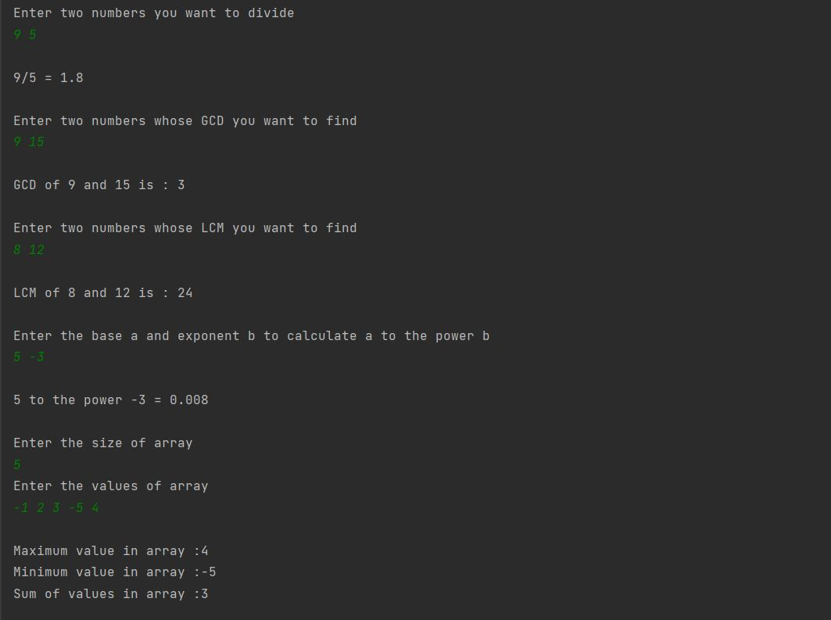

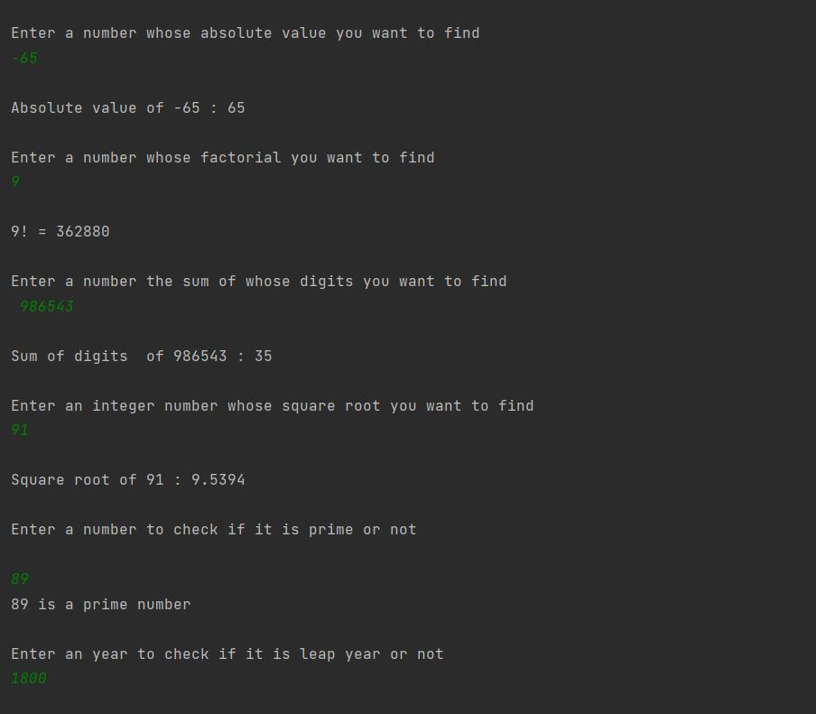

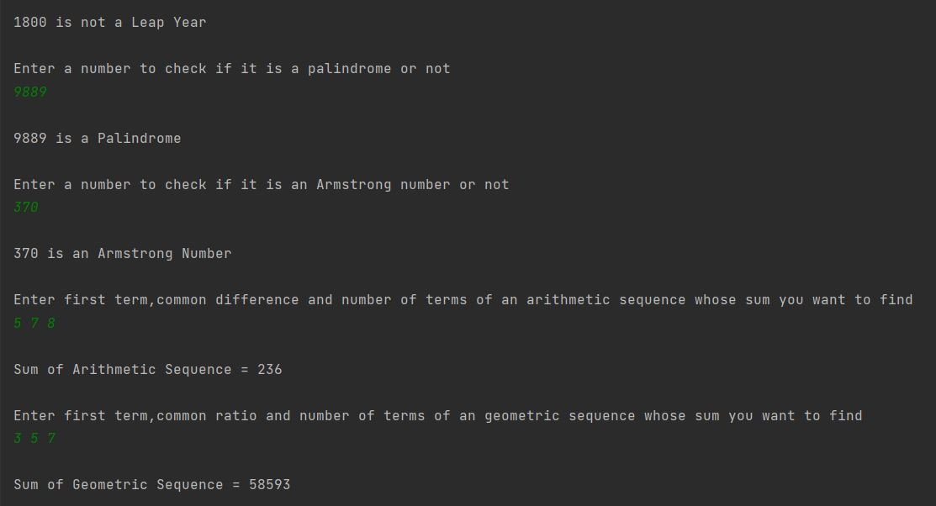

## 

## Creating a class named ReverseArray

CODE:

//package com.company;  
import java.util.*;  
public class reverseArray {  
 public static void main(String args[]){  
 Scanner Sc=new Scanner(System.*in*);  
 System.*out*.println("Enter size of array");  
 int s = Sc.nextInt();  
 int arr[] = new int[s];  
 int x,temp;  
 System.*out*.println("Enter array elements");  
 for(x = 0; x < s; x++) {  
 arr[x] = Sc.nextInt();  
 }  
 for(x = 0; x < s/2; x++) {  
 temp = arr[x];  
 arr[x] = arr[s-1-x];  
 arr[s-1-x] = temp;  
 }  
 System.*out*.println("The reversed array is");  
 for(x = 0; x < s; x++) {  
 System.*out*.print(arr[x]+" ");  
 }  
 }  
}

OUTPUT:

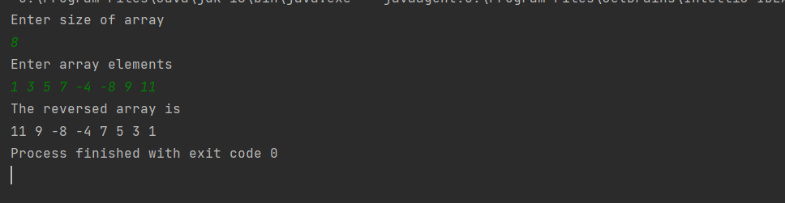

## Creating a class named MaxAbsDifference

CODE:

//package com.company;  
  
import java.util.*;  
public class MaxAbsDifference {  
 public static void main(String args[]){  
 Scanner Sc = new Scanner(System.*in*);  
 System.*out*.println("Enter size of array");  
 int s = Sc.nextInt();  
 int arr[] = new int[s];int x;  
 System.*out*.println("Enter array elements");  
 for(x = 0;x < s; x++) {  
 arr[x] = Sc.nextInt();  
 }  
 int min = arr[0], max = arr[0];  
 for(x = 1; x < s; x++){  
 if(arr[x] > max) max = arr[x];  
 if(arr[x] < min) min = arr[x];  
 }  
 System.*out*.println("The maximum absolute difference among the array elements is "+(max - min));  
 }  
  
}

OUTPUT:

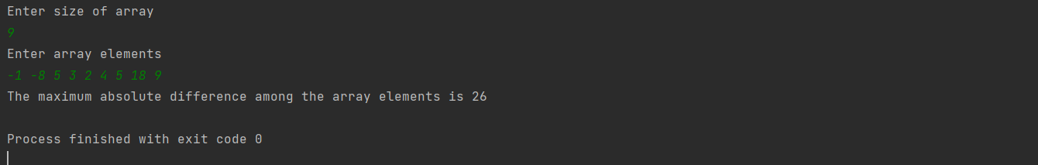

## Creating a class named AddMatrix

CODE:

//package com.company;  
  
import java.util.*;  
public class AddMatrix {  
 public static void main(String args[]){  
 Scanner Sc = new Scanner(System.*in*);  
 System.*out*.println("Enter the number of rows and columns of matrix 1");  
 int m = Sc.nextInt();  
 int n = Sc.nextInt();  
 int r, c;  
 int a[][] = new int[m][n];  
 System.*out*.println("Enter the elements of matrix 1 row-wise");  
 for(r = 0; r < m; r++) {  
 for(c = 0; c < n; c++) {  
 a[r][c] = Sc.nextInt();  
 }  
 }  
 //printing the matrix 1  
 System.*out*.println("Matrix 1");  
 for(r = 0; r < m; r++) {  
 for(c = 0; c < n; c++) {  
 System.*out*.print(a[r][c] +"\t");  
 }  
 System.*out*.println();  
 }  
  
 System.*out*.println("Enter the number of rows and columns of matrix 2");  
 int p = Sc.nextInt();  
 int q = Sc.nextInt();  
 int b[][] = new int[p][q];  
  
 System.*out*.println("Enter the elements of matrix 2 row-wise");  
  
 for(r = 0; r < p; r++) {  
 for(c = 0; c < q; c++) {  
 b[r][c] = Sc.nextInt();  
 }  
 }  
 //printing matrix 2  
 System.*out*.println("Matrix 2");  
 for(r = 0; r < p; r++) {  
 for(c = 0; c < q; c++) {  
 System.*out*.print(b[r][c] +"\t");  
 }  
 System.*out*.println();  
 }  
  
  
 if(m != p || n != q) System.*out*.println("Matrices can not be added");  
 else {  
 System.*out*.println("The sum of the matrices is ");  
 int sum[][] = new int[m][n];  
  
 for (r = 0; r < m; r++) {  
 for (c = 0; c < n; c++) {  
 sum[r][c] = a[r][c] + b[r][c];  
 System.*out*.print(sum[r][c] + "\t");  
 }  
 System.*out*.println();  
 }  
 }  
 }  
}

OUTPUT:

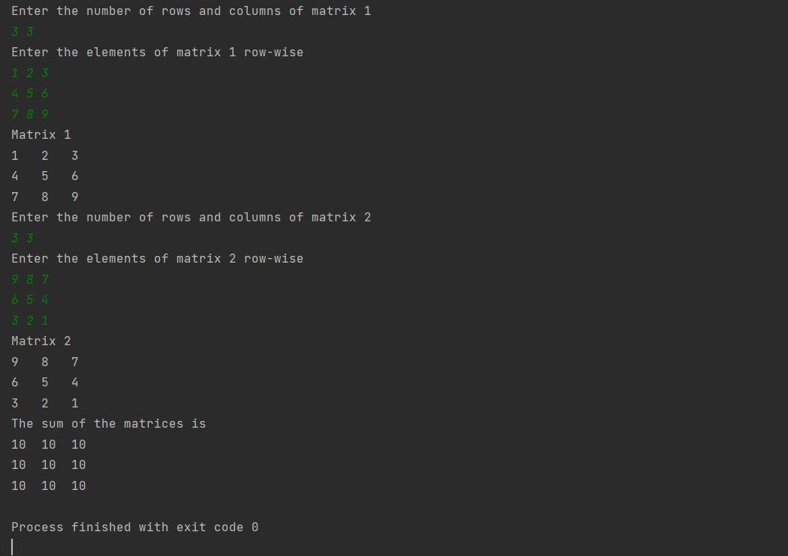

## Creating a class named MultiplyMatrix

CODE:

//package com.company;  
import java.util.*;  
  
public class MultiplyMatrix {  
 public static void main(String args[]){  
 Scanner Sc = new Scanner(System.*in*);  
 System.*out*.println("Enter the number of rows and columns for matrix 1");  
 int m1 = Sc.nextInt();  
 int n1 = Sc.nextInt();  
  
 int r,c;  
 int a[][] = new int[m1][n1];  
  
 System.*out*.println("Enter the elements of matrix 1 row-wise");  
 for(r = 0; r < m1; r++){  
 for(c = 0; c < n1; c++){  
 a[r][c] = Sc.nextInt();  
 }  
 }  
  
 //printing the matrix 1  
 System.*out*.println("Matrix 1");  
 for(r = 0; r < m1; r++) {  
 for(c = 0; c < n1; c++) {  
 System.*out*.print(a[r][c] +"\t");  
 }  
 System.*out*.println();  
 }  
  
 System.*out*.println("Enter the number of rows and columns for matrix 2");  
 int m2 = Sc.nextInt();  
 int n2 = Sc.nextInt();  
  
 int b[][] = new int[m2][n2];  
  
 System.*out*.println("Enter the elements of matrix 2 row-wise");  
 for(r = 0;r < m2; r++){  
 for(c = 0; c < n2; c++){  
 b[r][c] = Sc.nextInt();  
 }  
 }  
 //printing matrix 2  
 System.*out*.println("Matrix 2");  
 for(r = 0; r < m2; r++) {  
 for(c = 0; c < n2; c++) {  
 System.*out*.print(b[r][c] +"\t");  
 }  
 System.*out*.println();  
 }  
 if(n1 != m2){  
 System.*out*.println("Matrices can not be multiplied.");  
 System.*exit*(1);  
 }  
  
 int p[][] = new int[m1][n2];  
 int s;  
 System.*out*.println("The product of the matrices is");  
 for(r = 0; r < m1; r++) {  
 for(c = 0; c < n2; c++) {  
 s = 0;  
 for(int x = 0; x < m2; x++) {  
 s += a[r][x] * b[x][c];  
 }  
 p[r][c] = s;  
 System.*out*.print(p[r][c]+"\t");  
 }  
 System.*out*.println();  
 }  
 }  
  
}

OUTPUT:

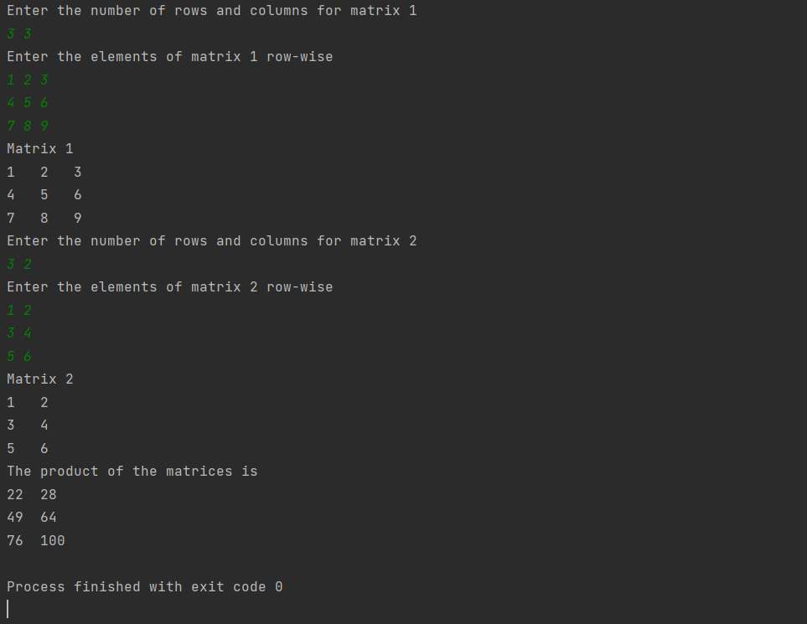

## Creating a class named Palindrome

CODE:

//package com.company;  
  
import java.util.*;  
public class Palindrome{  
 public static void main(String args[]){  
  
 Scanner Sc = new Scanner(System.*in*);  
 System.*out*.println("Enter a string to check if it is a palindrome or not");  
 String str = Sc.nextLine();  
 int x, c = 0, l = str.length();  
 for(x = 0; x < l/2; x++){  
 if(str.charAt(x) != str.charAt(l-1-x)){  
 c--;  
 break;  
 }  
 }  
 if(c == 0) System.*out*.println("PALINDROME");  
 else System.*out*.println("NOT A PALINDROME");  
 }  
}

OUTPUT:

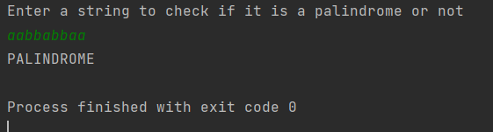

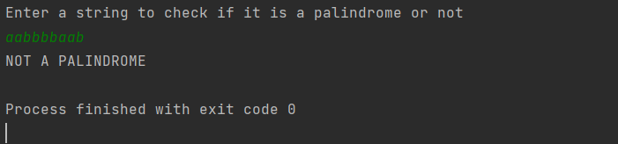

## Creating a class named IsNumeric

CODE:

//package com.company;  
  
import java.util.*;  
public class IsNumeric {  
 public static void main(String args[]){  
 Scanner Sc = new Scanner(System.*in*);  
 System.*out*.println("Enter a string to check if it contains only numbers or not");  
 String str = Sc.nextLine();  
 int x, c = 0;  
 for(x = 0;x < str.length();x++) {  
 char ch = str.charAt(x);  
 if(ch<48 || ch>57) {  
 c--;  
 break;  
 }  
 }  
 if(c==0) System.*out*.println("NUMERIC STRING");  
 else System.*out*.println("NOT A NUMERIC STRING");  
 }  
  
}

OUTPUT:

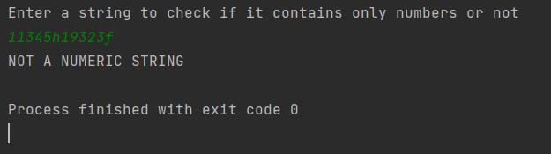

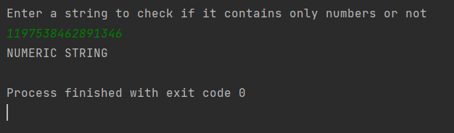

## Creating a class named IsEqual

CODE:

//package com.company;  
  
import java.util.*;  
public class IsEqual {  
 public static void main(String args[]){  
 Scanner Sc = new Scanner(System.*in*);  
 System.*out*.println("Enter string 1");  
 String s1 = Sc.nextLine();  
 System.*out*.println("Enter string 2");  
 String s2 = Sc.nextLine();  
 if(s1.length() != s2.length()){  
 System.*out*.println("NOT EQUAL");  
 System.*exit*(1);  
 }  
 int x, c = 0;  
 for(x = 0; x < s1.length(); x++) {  
 if(s1.charAt(x) != s2.charAt(x)){  
 c++;  
 break;  
 }  
 }  
 if(c == 0) System.*out*.println("EQUAL STRINGS");  
 else System.*out*.println("NOT EQUAL");  
 }  
  
}

OUTPUT:

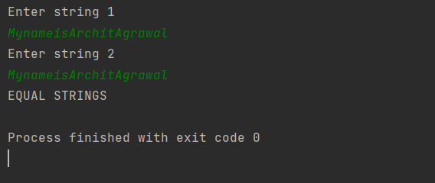

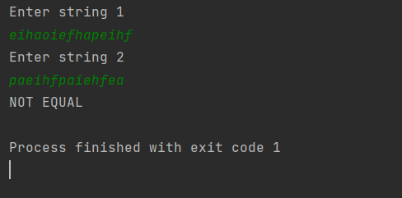

## 10. Creating a class named CharSort

CODE:

//package com.company;  
  
import java.util.*;  
  
public class CharSort {  
 public static void main(String args[]){  
  
 Scanner Sc = new Scanner(System.*in*);  
 System.*out*.println("Enter the string you want to sort");  
 String str = Sc.nextLine();  
 int x, y, l=str.length();  
 char temp;  
 char[]a = str.toCharArray();  
 str = "";  
 for(x = 0;x < l-1; x++) {  
 for(y = 0; y < l-1-x ; y++) {  
 if(a[y]>a[y+1]) {  
 temp = a[y];  
 a[y] = a[y+1];  
 a[y+1] = temp;  
 }  
 }  
 str = a[l-1-x] + str;  
 }  
 str = a[0]+str;  
 System.*out*.println("Sorted String is: " +str);  
 }  
}

OUTPUT:

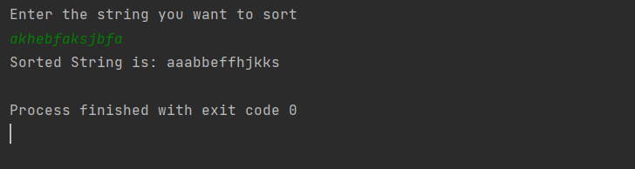

## 11.Creating a class named IsAnagram

CODE:

//package com.company;  
import java.util.*;  
  
public class IsAnagram{  
 public static void main(String args[]) {  
 Scanner Sc=new Scanner(System.*in*);  
 System.*out*.println("Enter String 1");  
 String s1=Sc.nextLine();  
 System.*out*.println("Enter String 2");  
 String s2=Sc.nextLine();  
 int a1[]=new int[256];  
 int a2[]=new int[256];  
  
 if(s1.length() != s2.length()) {  
 System.*out*.println("The two strings are not anagrams.");  
 System.*exit*(1);  
 }  
 int x;  
 for(x = 0; x < s1.length(); x++) {  
 a1[s1.charAt(x)]++;  
 a2[s2.charAt(x)]++;  
 }  
 int c = 0;  
 for(x = 0;x < 256;x++) {  
 if(a1[x] != a2[x]) {  
 c++;  
 break;  
 }  
 }  
 if(c == 0) System.*out*.println("The two strings are anagrams");  
 else System.*out*.println("The two strings are not anagrams");  
  
 }  
  
}

OUTPUT:

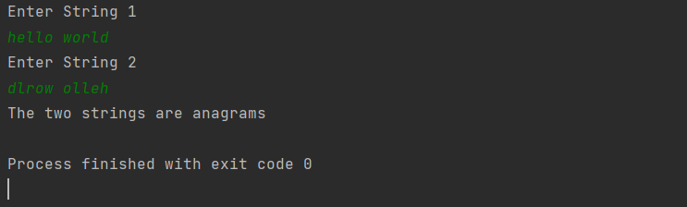

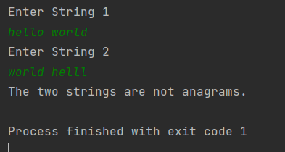

## 12.Creating a class named SingleCharacters

CODE:

//package com.company;  
  
import java.util.*;  
public class SingleCharacters {  
 public static void main(String args[]){  
 Scanner Sc = new Scanner(System.*in*);  
 System.*out*.println("Enter a string");  
 String str = Sc.nextLine();  
 int a[] = new int[256];  
 int x;  
 for(x = 0; x < str.length();x++) {  
 a[str.charAt(x)]++;  
 }  
 int count=0;  
 for(x = 0; x < 256; x++) {  
 if(a[x] == 1) count++;  
 }  
 System.*out*.println("Number of single occurring characters is "+count);  
 }  
  
}

OUTPUT:

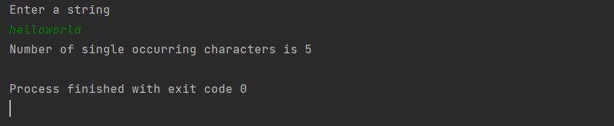

## 13.Creating a class named Binary

CODE:

package com.company;  
  
import java.util.*;  
public class Binary {  
 public static void main(String args[]){  
 Scanner Sc = new Scanner(System.*in*);  
 String str = Sc.nextLine();  
 int x, c = 1;  
 long dec = 0;  
 for(x = str.length()-1; x >= 0;x--) {  
 dec += (str.charAt(x)-48) * c;  
 c *= 2;  
 }  
 System.*out*.println("The decimal number is "+dec);  
 }  
  
}

OUTPUT:

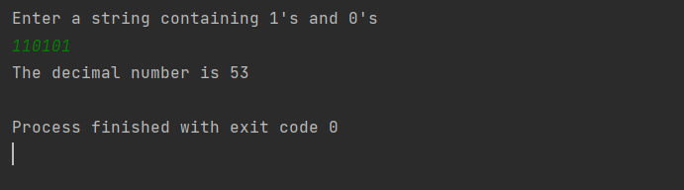

## 14.Creating a class named Decimal

CODE:

//package com.company;  
  
import java.util.*;  
public class Decimal {  
 public static void main(String args[]) {  
 Scanner Sc = new Scanner(System.*in*);  
 System.*out*.println("Enter an integer whose binary equivalent you want to find");  
 int num = Sc.nextInt();  
 System.*out*.print("Binary Equivalent of "+num+" = ");  
 String bin = "";  
 while(num > 0) {  
 bin = (char)(num%2+48) + bin;  
 num = num/2;  
 }  
 System.*out*.println(bin);  
 }  
  
}

OUTPUT:

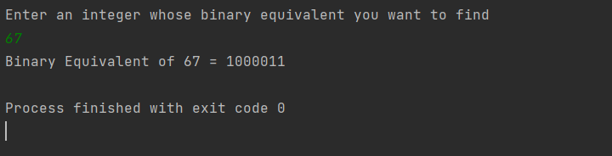

## 15.Creating a class named RightTriangle

CODE:

//package com.company;  
  
import java.util.*;  
public class RightTriangle {  
 public static void main(String args[]) {  
 System.*out*.println("Enter the number of rows of pattern");  
 Scanner Sc = new Scanner(System.*in*);  
 int rows = Sc.nextInt();  
 int r,c;  
 for(r = 0; r < rows; r++) {  
 for(c = 0; c <= r;c++) {  
 System.*out*.print("* ");  
 }  
 System.*out*.println();  
 }  
 }  
}

OUTPUT:

